A

Project Report on

**<The Bright Spark>**

Submitted in partial fulfillment of completion of the course

Advanced Diploma in IT, Networking and Cloud

Submitted by:

**Shikha Kumari**

**Shrimana Maity**

**Sarmistha Sharma**

**Roshni Verma**

Under Guidance of:

**Ms. Arpita Roy (Edunet)**

|  |  |  |
| --- | --- | --- |
| IBM-Logo - Chicago Innovation | DGT introduces high end diploma courses - digitalLEARNING Magazine | Edunet Foundation-Delhi- CSR Organization profile |

Year 2022

Abstract

Acknowledgement

Team Composition and Workload Division

Table of Contents

1. Introduction to Problem
2. Literature Review
3. Proposed Solution
4. Requirements

4.1 Technology Stack

4.2 Hardware

4.3 Software

4.4 Deployment Environment

5. User Requirements

6. Design Documentation

7. Implementation Details

8. Testing

9. Deployment

10. Future Scope

11. Conclusion

Appendix A Project Code

Appendix B Screenshot of Project

Appendix C abbreviation

References

***Abstract:***

The basic idea is to allow self-determining and confidential communication to exchange of data between real-world devices and applications of the Internet of things. Computer network area requires professionals with solid networking theory and practical hands-on experience.

Together with the fast technological advancement in the field of computer networks and Information

Technology industry, the need for a large number of skilled network experts also increased .

Cisco Packet Tracer is an effective education simulation software that supports computer networking students to experiment and practice network tasks. Cisco Networking Academy Program(CNAP) introduced Packet Tracer as a tool for teaching and learning of computer network courses by providing “simulation, visualization, authoring, collaboration capabilities and assessment”

Cisco Packet Tracer is a tool built by Cisco and it provides network simulation to practice simple and complex networks. The main purpose of the Cisco Packet Tracer is to help students learn the principles of networking and demonstrate the networking concepts. A DHCP Server is a network server that automatically assigns IP addresses, default gateways, and other network parameters to client devices.

***Acknowledgement :***

Team ‘The Bright Spark’ (comprising of 4 members, namely Shikha Kumari, Shrimana Maity, Sarmistha Sharma, Roshni Verma ) are thankful to our teacher, Ms. Arpita Roy for her guidance and supervision which has provided a lot of resources needed in completing our project.

We are also thankful to the efforts put in by our team members and contributions to the preparation of this project.

Table of Contents

1. Introduction to Problem

Computer network area requires professionals with solid networking theory and practical hands-on experience. Together with the fast-technological advancement in the field of computer networks and Information Technology industry, the need for a large number of skilled network experts also increased.

Cisco Packet Tracer is an effective education simulation software that supports computer networking students to experiment and practice network tasks.

2.Proposed Solution

The use of virtual laboratories is very important. In this study, we also implemented Cisco Packet Tracer, which enables us to work on test scenarios without using any physical components virtually to design an advanced computer network. The Cisco Packet Tracer is used not only to simulate computer networks but also to learn computer networks.

3.Requirements

3.1 Technology Stack: Networking

* 1. Hardware:

Processor: Intel(R) Core (TM) i5-9500 CPU @ 3.00GHz 3.00 GHz

Installed RAM 8.00 GB (7.81 GB usable)

System type 64-bit operating system, x64-based processor

* 1. Software: CISCO Packet Tracer
  2. Deployment Environment: It is deployed in CISCO Packet Tracer

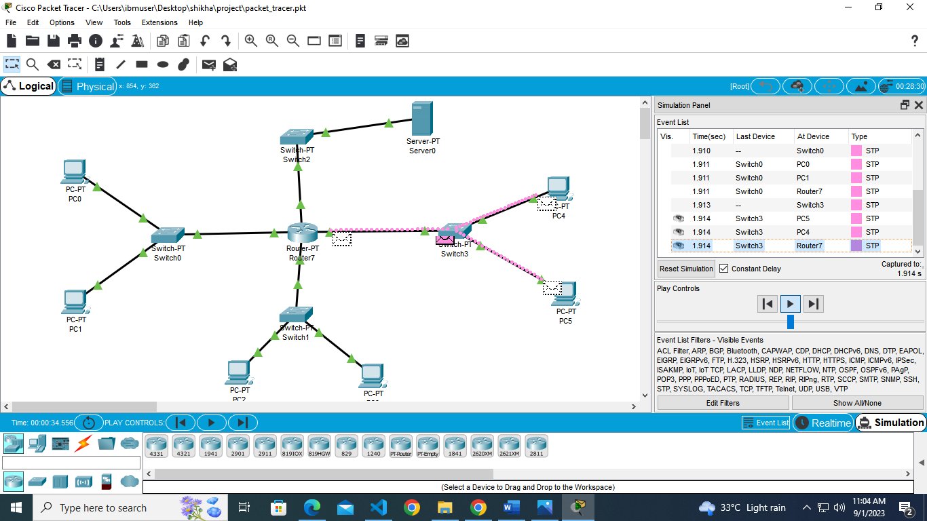

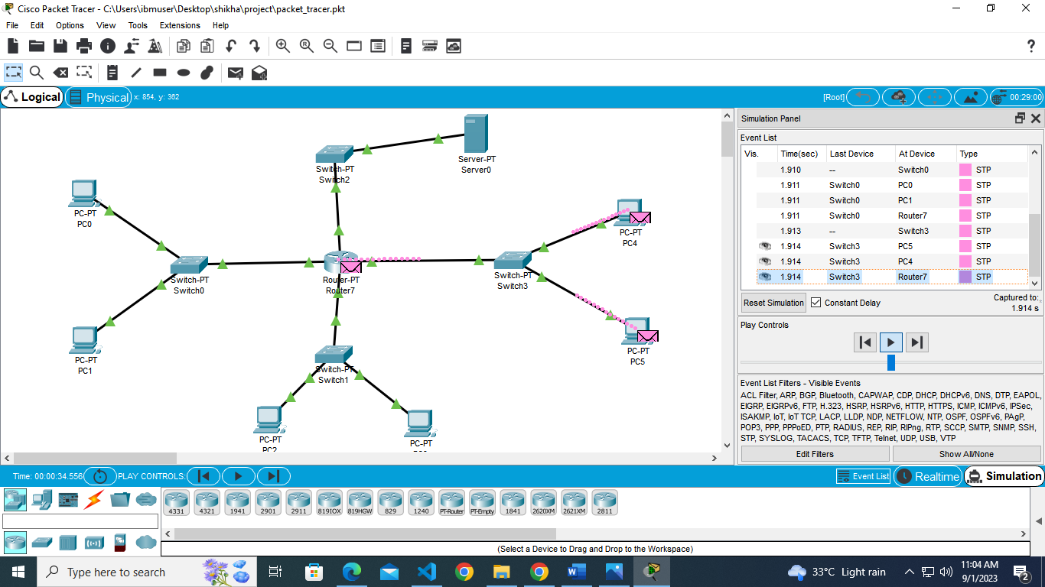

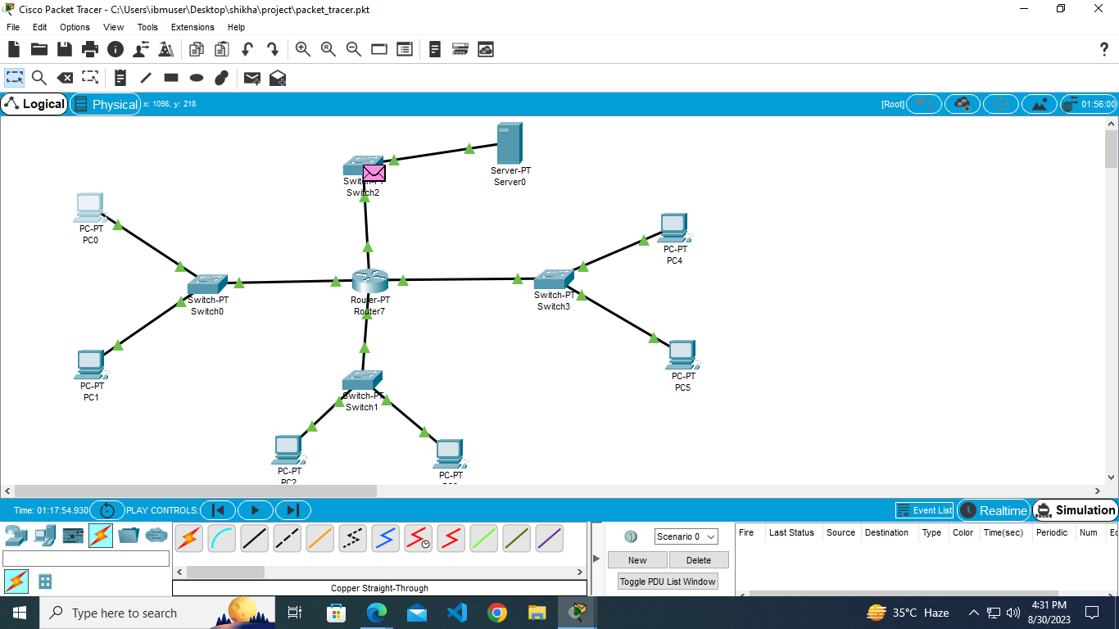

Instructions:

1. Font- Arial
2. Main /Title Heading- 16 (bold, center aligned)
3. Heading-14 (bold)
4. Sub heading-12 (bold)
5. Normal text-12
6. Text Alignments- Justified
7. Image/Screenshot/Table Alignments- Center
8. Caption below Images/screenshot/table - Centre, Font size 8
9. References to be numbered in square box like [1] ….
10. Any code to be attached as appendix at the end like Appendix A, Appendix B …
11. Screenshots of project can also be attached as appendix

**Literature Review**

**Reviewing Literature**

**A literature review** in a thesis is a critical review of literature relevant to your field of study. It’s not a summary of the whole field, or a haphazard regurgitation of everything you’ve read in the field but an organized and critical discussion that lets your reader see what you’ve ‘made’ of the literature relevant to the topic of your thesis and your research question. It functions to contextualize your research within that research field by identifying where there are gaps in previous research that your own research will help to fill. To see how a literature review can be organized so that it provides a critical review of the field relevant to the thesis topic and shows how previous research both informs and provides a rationale for the suggested research, see the annotated discipline examples.

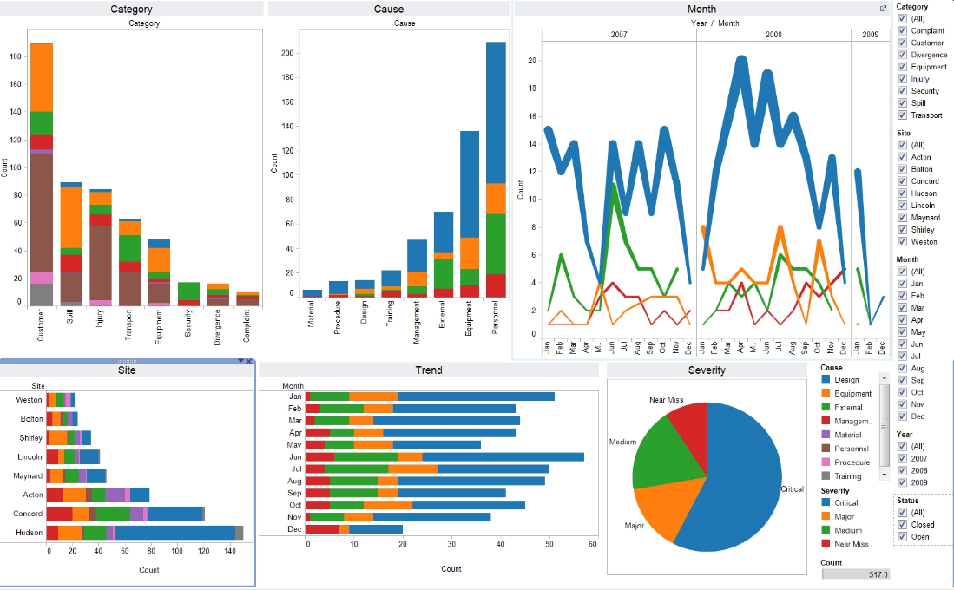

Image:1 Data visualization of electronics manufacturing market Reference: [data_visualization_python.jpg (1658×1026) (wp.com)](https://i1.wp.com/www.simplifiedpython.net/wp-content/uploads/2018/07/data_visualization_python.jpg?resize=1658%2C1026&ssl=1)

**Appendix A**

**Project Code**